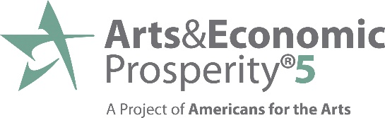

Arts Facts . . . Economic Impact of the Arts
The nonprofit arts industry generated $166.3 billion in total economic activity in 2015—supporting 4.6 million jobs and generating $27.5 billion in government revenue.

Economic Impact of the Nonprofit Arts and Culture Industry

Total Economic Activity $166.3 Billion
Direct spending by nonprofit arts and cultural organizations $63.8 Billion
Direct spending by cultural audiences $102.5 Billion

Total Full-Time Equivalent Jobs Supported 4.6 Million

Total Household Income Generated $96.1 Billion

Total Government Revenue Generated $27.5 Billion
Federal income tax revenue $12.9 Billion
State government revenue $7.7 Billion
Local government revenue $6.9 Billion
- Nonprofit arts and cultural organizations are valued members of the business community. They employ people locally, purchase goods and services locally, are members of their Chambers of Commerce, and promote their regions.
- In 2015, these organizations—performing and visual arts organizations, festivals, public art programs, municipally owned museums and arts centers, and more—pumped an estimated $63.8 billion into the nation’s economy. This economic activity leveraged an additional $102.5 billion in event-related spending by arts audiences. The $166.3 billion in total economic activity supported 4.6 million full-time equivalent jobs and generated $27.5 billion in total government revenue.
- When patrons attend an arts event, they may pay for parking, eat dinner at a restaurant, shop in local retail stores, and have dessert on the way home. Based on the 212,691 audience surveys conducted for this study, the typical attendee spends $31.47 per person, per event, beyond the cost of admission. 34% of attendees came from outside the county in which the arts event took place. They spent twice as much as their local counterparts ($47.57 vs. $23.44).
- Arts & Economic Prosperity 5 demonstrates that the arts are an industry that supports jobs, generates government revenue, and is a cornerstone of tourism. Business and elected leaders need not feel that a choice must be made between arts funding and economic prosperity. This study proves that they can choose both. Nationally as well as locally, the arts mean business!

Visit www.AmericansForTheArts.org/AEP5 for more information about the Arts & Economic Prosperity 5 study.

